**C-Basic_Assignment_2b**

STR/01 Write a function to accept a sentence (that is a line) from the user.

Ans:#include <stdio.h>

#define MAX 15

int main()

{

char buf[MAX];

fgets(buf, MAX, stdin);

printf("string is: %s\n", buf);

return 0;

}

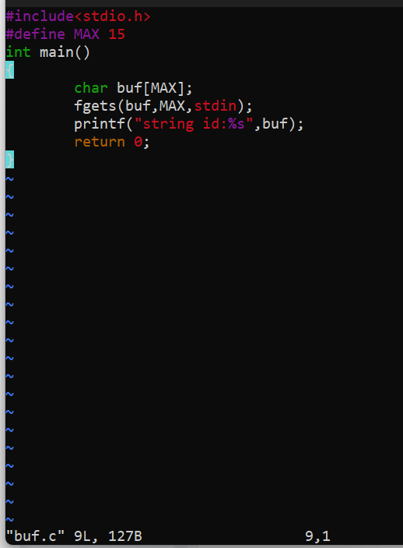

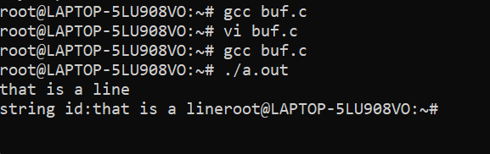

STR/02 Write a function which accepts the sentence and prints one word in a line. A word is a sequence of non-whitespace characters

Ans:

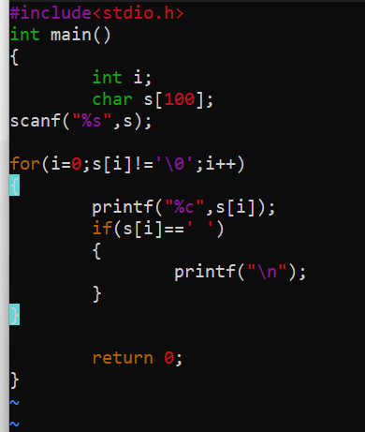

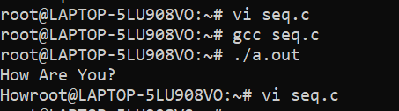

STR/03 Write a function to print the longest word in the sentence (assume all words are of different length).

Ans:

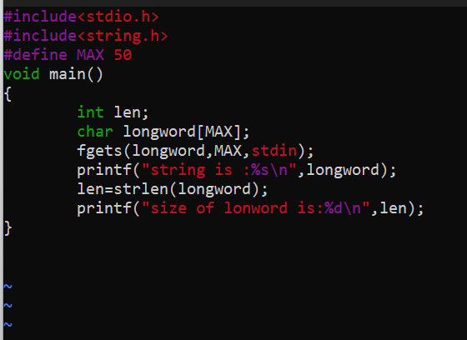

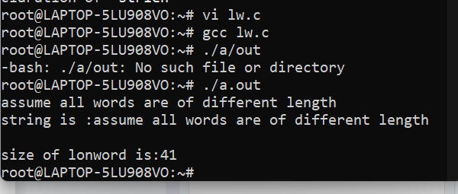

STR/04 Write a function to prompt and read a search sub string, search for the first word containing this substring in input sentence, remove the word and display the sentence after update.

Ans:

STR/05 Print all words in one line without printing any whitespace

Ans:

/* C program to remove spaces from a string */

#include<stdio.h>

char *remove_white_spaces(char *str)

{

int i = 0, j = 0;

while (str[i])

{

if (str[i] != ‘ ‘)

str[j++] = str[i];

i++;

}

str[j] = ‘\0’;

return str;

}

int main()

{

char str[50];

printf("\n\t Enter a string : ");

gets(str);

remove_white_spaces(str);

printf(“%s”,str);

return 0;

}